**Requirements**  
Create a History main view that function as similar as possible to the Activity main view with all the existing features of a regular mainview present.

Additional Required features:   
History type column and filter  
Link to History dialog detail view

**Steps Taken**   
These steps are completed in the associated bundle and they do not need to be repeated. The items below are for reference when reviewing the updates, to see how they were accomplished.   
There are some small actions required. These are noted below as “**Action Item:”**

1. Create the History Manager page
   1. Open AA
   2. In Portal Manager > Sage SalesLogix > Pages( R+click) > Add Main View
      1. Normally we would recommend the wizard in this scenario. However, since there is a History.aspx page already, we need this page to be aliased HistoryManager.aspx
      2. Because there is a conflicting History.aspx page, group list behaviour will often redirect to that page. We can’t have that, so we create a HistoryManagerController.ascx smart part designed to load in list mode of the History.aspx and redirect to the list mode of HistoryManager.aspx. We can do this because we know History.aspx should never display in list mode.   
         That is what our new view is for.
   3. **Action Item:** There is no OOTB History icon, you’ll have to add your own to the entity page and nav item.
   4. Page Properties
      1. EntityTypeName  
         Sage.Entity.Interfaces.IHistory, Sage.Entity.Interfaces
2. Create History Filters
   1. The Type filter is going to be similar to the Acitivty Type filter. Using ranges to determine the Type display value.
   2. **Action Item:** Did not put all the filters in. Left for specific customization.
3. Add Left Nav item
   1. No context menu has been added
4. Build/Deploy
5. Create default Group
6. Create global join from History to Picklist. (Fig.1) We are going to use the picklist to display the History type display name. You will need to make sure that your history entity type enum and activity picklist are in sync. If the global join does not show up after created, delete the record from sysdba.Plugin where PLUGINID = ‘XMLSCHEMA’

Fig.1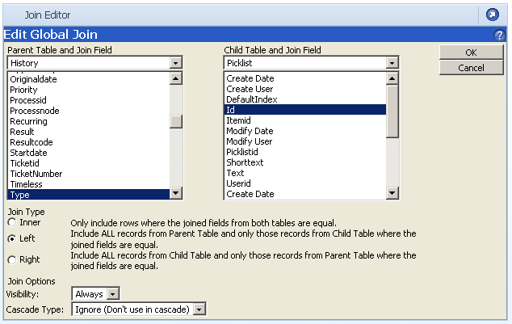

1. Add group layout.
   1. **Action Item:** Not all columns have been added. Left for specific customization.
2. Add a condition to only get results for the Acitivty Type picklist, ‘KSYST0000001’.   
   **Action Item**: You may have to go lookup your Acitivity Type picklist Id.
   1. Note: At this point, icons are not available in this grid and the link to the history dialog needs to be on a field that is directly on History; Completed Date, Description, etc. The display value of the picklist is not available for linking to the history dialog.